**Warrnambool Arts and Lost Trades Festival - Localised event food catering app prototype**

Team members:

* Le Duc Thinh Bui (Leader)
* Tristan Farrell Budiman
* Lovish Bansal
* Muhammad Rafi Azka
* Piyush Arora

# 

# **1. Executive Summary**

This report covers the design of a mobile app prototype for the Warrnambool Arts and Lost Trades Festival. The goal was to help local food vendors get more visibility and make it easier for visitors to find and book food or event tickets. Our team followed Agile methods and worked over five sprints to build the app step by step.

The final app lets users sign up, browse stalls and events, book tickets, save favourites, and leave reviews. Vendors can manage their menus and orders, organisers can set up events, and admins can control approvals and track data. We also included sponsor ads, like Kermond’s Hamburgers, to support local businesses.

Each team member had a clear role, and we worked closely through regular meetings and feedback. By the end, we delivered a working, easy-to-use app that met the client’s needs and is ready for future improvements or launch.

**1. Executive Summary 2**

**2. JIRA User Stories and Sprint Backlogs 4**

**3. Burndown Charts 5**

Sprint 1: Introduction to Jira 6

Sprint 2: Logo and Login Page 6

Sprint 3: Browse List of Food Stalls 7

Sprint 4: Visual Theme and UI Completion 8

Sprint 5: Final MVP Completion 8

**4. Stand-Up Meetings 9**

**5. Sprint Retrospective Meetings 10**

Sprint 1 - Retrospective 10

Sprint 2 - Retrospective 11

Sprint 3 - Retrospective 12

Sprint 4 - Retrospective 13

Sprint 5 - Retrospective 15

**6. Minimum Viable Product (MVP) 16**

**7. Teamwork for the project 17**

7.1. Role Allocation and Module Responsibilities 17

7.2. Agile Meetings and Communication 18

7.3. Conflict Resolution 18

7.4 Client Alignment 19

**8. Prototype Development 19**

Sprint 1: Wireframe Planning and Miro Familiarisation 19

Sprint 2: Initial Prototype Based on User Stories 20

Sprint 3: Full App Draft Aligned with Stakeholder Expectations 21

Sprint 4: Expanded Role-Based Functionality (Admin, Event Organiser, Vendor) 21

Sprint 5: Final Design Refinement for Client Presentation 23

**Appendix 25**

Sprint 1: 25

Sprint 2: 28

Sprint 3: 34

Sprint 4: 39

Sprint 5: 45

# **2. JIRA User Stories and Sprint Backlogs**

We used JIRA to plan and manage our work, creating 95 user stories over five sprints. These stories covered different features for visitors, vendors, organisers, and admins. Each story followed the format: “As a [user], I want to [do something], so I can [get a result],” and we used the Fibonacci scale to estimate effort.

Each story also followed a clear Definition of Done (DoD) to make sure it was truly complete. For our project, a story is done when it had:

* Been reviewed by team members
* Shows in the prototype in each sprint
* Met the acceptance criteria
* And was approved by the Product Owner

Each sprint we have done:

* **Sprint 1**: 8 – setting up tools like JIRA and Miro
* **Sprint 2**: 23 – login, sign-up, vendor browsing, and booking
* **Sprint 3**: 35 – vendor menus, reviews, booking history, and navigation
* **Sprint 4**: 19 – role-specific dashboards and app design
* **Sprint 5**: 10 – sponsor ads, site map, and final report

As the project went on, the tasks got more complex, especially in the middle sprints. We kept our backlog updated with feedback and made sure things stayed on track.

To show how we used Agile and focused on users, we’ve included three example stories from different roles and sprints.

**Selected User Stories**

**Story ID: MIT125BW51-32  
Story:**As a visitor, I want to browse a list of food stalls, so I can see what’s available at the festival.

* **User Type:** Visitor
* **Story Points:** 3
* **Sprint:** Sprint 2
* **Acceptance Criteria:**
  + Users can scroll through a list of stalls
  + Each stall includes name, image, and cuisine tags
* **Status:** Done
* **Reflection:** This was one of the first features implemented. Midway through Sprint 2, we added a sorting option after receiving peer feedback. It helped us understand user navigation design and front-end integration.

**Story ID: MIT125BW51-60  
Story:**As a vendor, I want to preview how my stall appears in the app, so I can confirm my logo, name, and schedule are correct before the event.

* **User Type:** Food Vendor
* **Story Points:** 5
* **Sprint:** Sprint 2
* **Acceptance Criteria:**
  + Vendors can preview their stall profile
  + Preview includes logo, name, description, and event times
* **Status:** Done
* **Reflection:** This story helped us understand the vendor perspective. It was important to get the layout and data display right, especially for branding. We also learned how to conditionally render vendor content based on user role.

**Story ID: MIT125BW51-78  
Story:**As a visitor, I want to leave ratings and reviews after booking, so I can help others make better choices.

* **User Type:** Visitor
* **Story Points:** 8
* **Sprint:** Sprint 3
* **Acceptance Criteria:**
  + Review option appears only after a completed booking
  + Users can rate from 1 to 5 stars and submit a written review
* **Status:** Done
* **Reflection:** This story taught us how to manage feature conditions and form validation. It also showed us how user feedback can be captured after a transaction, and how it contributes to community trust.

# **3. Burndown Charts**

Our team used burndown charts to track progress and sprint performance across all five sprints. The charts provided insights into how effectively tasks were managed, highlighting trends in team workflow, collaboration, and estimation accuracy.

#### **Sprint 1: Introduction to Jira**

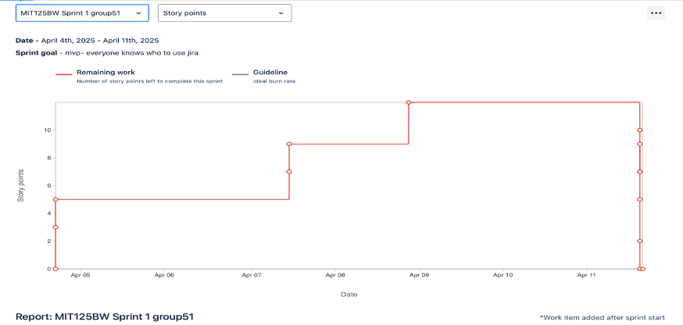

* **Goal:** Ensure all team members understand how to use JIRA.
* **Chart Insight:** The chart spiked early because we mistakenly opened the sprint before finalising our backlog.
* **Learning:** We learned to set up the backlog first before starting the sprint to avoid early confusion in JIRA.

#### **Sprint 2: Logo and Login Page**

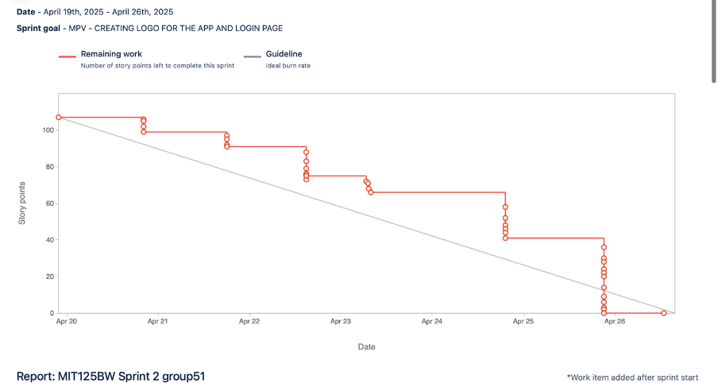

* **Goal:** Create app logo and login functionality.
* **Chart Insight:** Tasks were completed in multiple stages but still showed large clusters of work finished late in the sprint.
* **Learning:** Slight improvement in workflow and better use of JIRA. However, there was still a tendency to push work toward the sprint's end. We realised that better planning and daily updates could help balance the workload.

#### 

#### **Sprint 3: Browse List of Food Stalls**

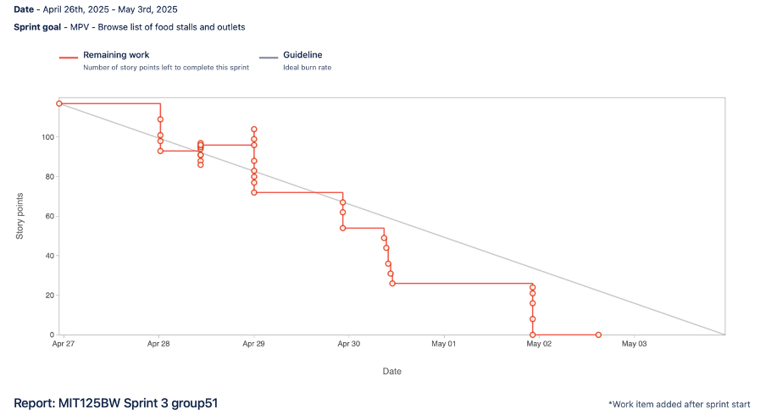

* **Goal:** Enable browsing of stalls and outlets in the app.
* **Chart Insight:** Mid-sprint, one team member was mistaken that we shouldn’t change the story points so the chart has some spike. Overall, this sprint was good.
* **Learning:** We learned to handle it more carefully and also recognised the need to freeze requirements or manage changes more formally. Prioritising tasks helped us stay on track.

#### 

#### 

#### 

#### 

#### 

#### 

#### **Sprint 4: Visual Theme and UI Completion**

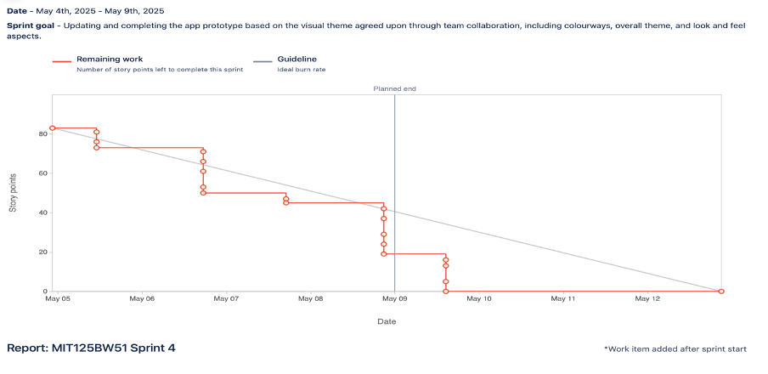

* **Goal:** Complete UI aspects including colourways and overall app theme.
* **Chart Insight:** This sprint had the smoothest burn. Tasks were completed steadily and the team kept close to the ideal burn rate.
* **Learning:** Excellent improvement in collaboration and daily stand-ups. Tasks were distributed more evenly, and team velocity improved. We used Fibonacci estimations more effectively for task sizing.

#### **Sprint 5: Final MVP Completion**

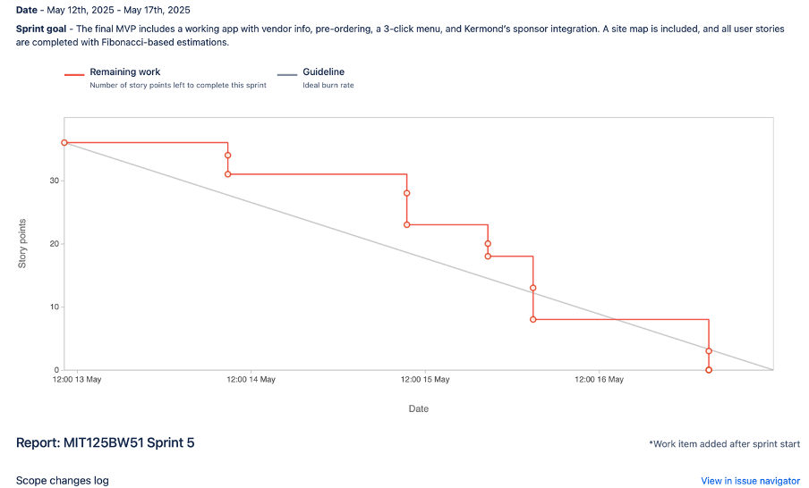

* **Goal:** Deliver full working MVP with vendor info, 3-click menu, pre-ordering, and sponsor integration.
* **Chart Insight:** A small amount of work was added mid-sprint (noted with asterisk). Despite this, the team finished with minimal remaining story points and kept a fairly smooth progress.
* **Learning:** Our best sprint in terms of task management and teamwork. We stayed close to the burndown guideline and were able to absorb additional scope without delay.

Overall, the burndown charts helped us reflect on how we worked as a team and improve our sprint management. By Sprint 4 and 5, our workflow had matured significantly, showing better planning, collaboration, and delivery consistency.

# **4. Stand-Up Meetings**

Stand-Up meetings were an essential element of our Agile practice, promoting alignment, accountability, and early problem-solving. These meetings were typically held at 9:00 PM on days agreed upon by all team members, ensuring availability across varying schedules. Each sprint also began with a planning session conducted during the Friday computer practical lab class, where the tutor outlined sprint expectations and deliverables. This initial alignment significantly improved our understanding of sprint goals and helped set up structured collaboration from day one.

In all Stand-Up meetings, the team followed a consistent framework based on four core Agile questions:

1. What did you do yesterday?
2. What are you working on now?
3. What will you do next?
4. Are there any roadblocks or issues?

These sessions were focused and action-driven. Team members gave clear updates on task progress, clarified deliverables, and discussed blockers that could impact the sprint timeline. For example, during Sprint 5, the team identified that sponsor advertisement content was received late, which delayed integration. This was addressed early through task redistribution and additional coordination on MS Teams.

Participation was strong across all Stand-Ups. Each member actively contributed updates and feedback, showing high engagement and shared ownership of the project outcomes. Meeting minutes were regularly recorded and uploaded to our Microsoft Teams folder for transparency and future tracking.

As the project progressed, Stand-Ups evolved into high-performing routines that reflected strong collaboration, excellent anticipation of issues, and a disciplined focus on sprint objectives. This ensured that the team remained aligned with the sprint backlog and MVP goals at every stage.

# **5. Sprint Retrospective Meetings**

Sprint retrospectives were a critical reflection tool throughout the whole project in order to improve effectiveness and collaboration. These meetings allowed the team to reflect on our accomplishment, inefficiencies, communication patterns, and technical obstacles. The retrospectives also helped us align better on future priorities and make tactical adjustments in the middle of the project. Key observations were casually recorded throughout all sprints using Microsoft Teams and JIRA boards.

#### Sprint 1 - Retrospective

Sprint 1 served primarily as a foundation-setting sprint. As this was our team’s first practical experience working an agile methodology, much of the focus was spent on learning how to generate user stories in JIRA, populate the backlog, and design initial wireframes in Miro. Although there were no official retrospective, we did do an informal post-sprint reflection on teams. which revealed several key insights:

* **What worked well:** Initial work distribution went smoothly, with role allocation clearly established for each app module ( Vendor, Visitor, Admin, and Organizer). The Microsoft Teams space was created promptly, and all members began contributing to the JIRA backlog. The MIRO board was also initiated, giving structure to early wireframe drafts.
* **What didn’t work:** We encountered uncertainty on how to properly write and estimate user stories. Our story points lacked consistency, and some user stories were too broad or vague. We also underestimated how long it would-take to coordinate work across different schedules outside lab hours.
* **Improvement:** We agreed to create more refined user stories with a more focused scope, estimate more effort on sprint planning, and schedule regular check-ins outside the lab to ensure ongoing progress visibly.
* **Team Effectiveness:** Despite the obstacles, team engagement was strong. All members contributed ideas during initial planning and demonstrated commitment to their assigned module. Communication was respectful and proactive. While sprint 1 was more exploratory and productive in deliverables, it established a strong interpersonal and structural basis that supported smoother collaboration in later sprints.

#### Sprint 2 - Retrospective

Sprint 2 focused on designing the visual foundation of the app, including the splash screen, navigation menu, sub-menus, and the first content page. The retrospective was conducted in a structured format and led to several valuable insights:

* **What worked well:** Team members reported strong understanding of responsibilities and clear progress in their assigned modules. Meetings were frequent and well-attended while the task completion was also on schedule.
* **What didn’t work:** Issues were noted with user story clarity and occasional overlap in task responsibilities due to insufficient communication during prior meetings and execution.
* **Improvement:** Greater creativity was encouraged, and team members suggested taking a more proactive approach in task ownership, decision-making, and peer support.
* **Team Effectiveness:** Communication was active even though there was an issue due to it being insufficient. The retrospective reinforce that Teams meeting and shared decisions were essential to our efficiency.

#### Sprint 3 - Retrospective

Sprint 3 focused on introducing core interactive features such as customer booking, vendor menu upload, and food outlet site displays. The retrospective for this sprint was particularly important due to the increased complexity of the deliverables:

* **What worked well:** Communication among group members improved and the app prototype in Miro progressed significantly based on refined user stories, Sprint task were completed as a team, and MVP goals were met, especially in booking and vendor development.
* **What didn’t work:** Story point tracking through the burndown chart was inaccurate due to a misalignment in task updates. Some delays occurred due to inefficient time management.
* **Improvement:** More specific user story creation was needed, along with better time. allocation for individual tasks. all members were encourage to be more actively involved
* **Team Effectiveness:** Moral and team synergy were high. Multiple members noted on how communication improved with each sprint. However, punctuality and full engagement during sprint activities were raised as an area for improvement.

#### Sprint 4 - Retrospective

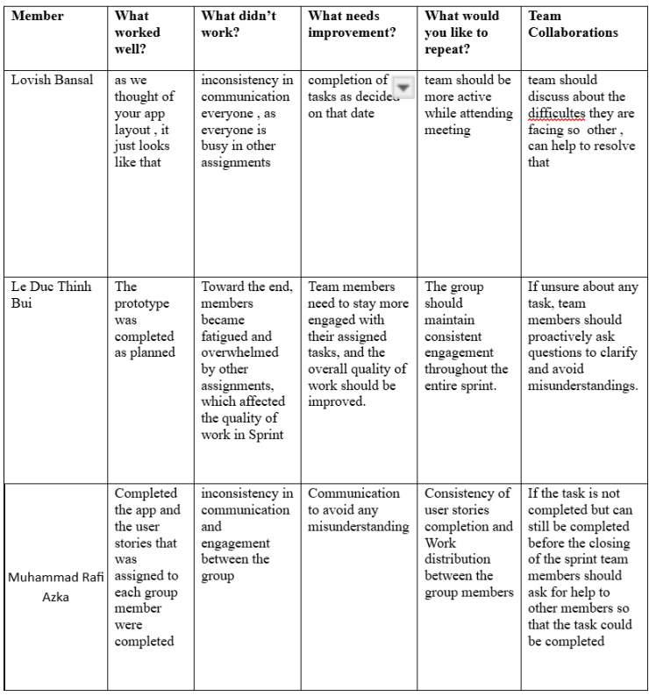

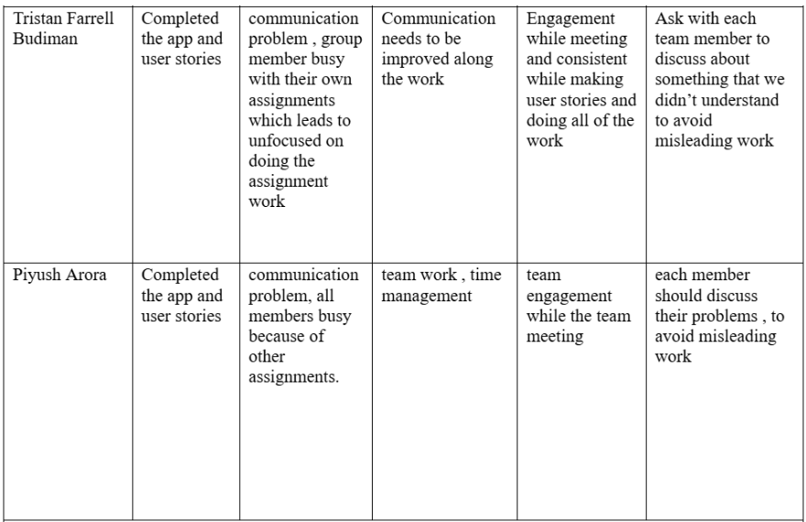

Sprint 4 concentrated on visual standardisation, including adoption of a group-wide colour palette, logo, font styling, and consistent spacing. This sprint also marked the full finalization of all modules:

* **What worked well:** The prototype was completed according to the shared group template. Branding (font, colour palette, layout) was consistently applied. Ever members was also able to finalized all their respective modules.
* **What didn’t work:** Reduce engagement was observed towards the end of the sprint, largely due to other academic commitment. Communication inconsistency impacted the final two days of development.
* **Improvement:** Members emphasised on maintaining steady participation and proactive asking questions when tasks were unclear. Cross-Checking wireframes between members was also suggested.
* **Team Effectiveness:** While successful overall, some group members were less engaged than in previous sprints. Team communication remained open, but clarity in expectations and task ownership was reinforced as a priority.

#### Sprint 5 - Retrospective

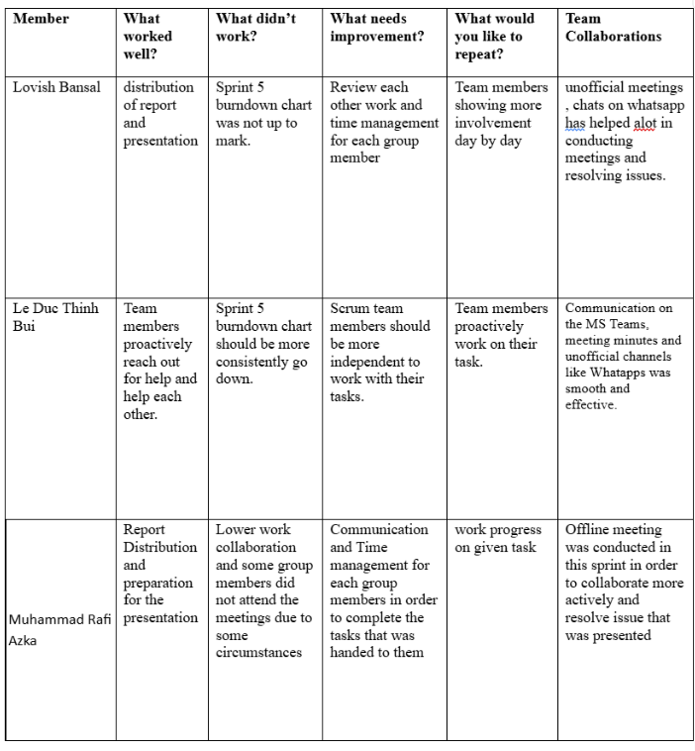

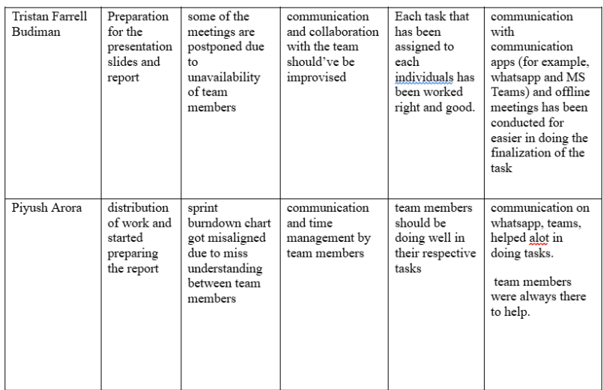

Sprint 5 marked the final development cycle of our project and focused on full module integration, UI polishing, and preparation for the final report and presentation. The final retrospective revealed key points and evaluate on how the team worked in this final sprint:

* **What worked well:** The final prototype was completed to a high standard, and team members actively worked on refining assigned sections of the application. Offline meetings, informal WhatsApp chat, and Microsoft Teams communication also helped streamline coordination, especially for finalising documents
* **What didn’t work:** One recurring issue was the inconsistency of sprint 5 burndown chart, which did not accurately reflect real-time task completion. This was primarily due to misunderstandings in JIRA updates and delays in synchronising status changes. In addition, some meetings were postponed and missed due to availability conflicts, leading to minor misalignment in collaboration during sprint 5
* **Improvement:** The team agreed that time management and attendance need to be more disciplined, especially during final delivery periods. Clearer communication about responsibilities, combine with timely updates in JIRA, would have improved sprint pacing. Team members should also become more independent when handling individua task, while still maintaining open communication
* **Team effectiveness:** Despite some coordination challenges, overall collaboration was strong. Members expressed that communication across both official (Microsoft Teams) and unofficial (WhatsApp) channel was smooth and helpful. Offline meetings helped resolve issues more effectively and an increase in initiative was noticeable especially in the creation and finalization of the presentation slides and project report

# **6. Minimum Viable Product (MVP)**

Throughout the five sprints, our team developed and improved the app prototype step by step, based on client expectations and the goals set for each sprint. The MVP (Minimum Viable Product) changed as the app progressed, reflecting both the increasing complexity of the project and the new features added over time.

In **Sprint 1**, the main goal was to set up the tools, roles, and structure for the app development. We created a basic layout using Miro to understand how to design wireframes and map user flows. The MVP for this sprint was to have a clear plan for the app, along with a working JIRA board and a defined team structure. This included setting up Microsoft Teams, creating the first user stories, and confirming our Stand-Up meeting schedule.

In **Sprint 2**, we designed the first working version of the app. This included important screens like the loading page, login and sign-up pages, vendor and event homepages, booking pages, and confirmation screens. We also added the favourite lists for both vendors and events. These features allowed users to sign in, browse vendors and events, book tickets, and view their bookings. This version met the Sprint 2 MVP as it demonstrated the core user journey from login to booking.

In **Sprint 3**, we refined and completed a full draft of the app based on the product backlog and feedback from our client. We added more detailed vendor menus, booking confirmations with driving times, and booking summaries. The bottom navigation bar was also added to improve the user experience. These updates allowed us to deliver a fully interactive prototype that reflected the client's vision and fulfilled all key requirements. The MVP was considered complete as the app allowed full functionality for a standard user.

In **Sprint 4**, we expanded the app to include different user roles such as Admin, Event Organiser, and Food Vendor. The Admin panel could approve vendors and organisers, manage users, and view summary data. Event Organisers were able to create and manage events, track attendees, and view feedback. Vendors could upload and edit dishes, handle orders, and reply to reviews. During this sprint, all teams worked together to apply a shared design, using the same colour palette, font style, and logos. This ensured that the app looked consistent. The MVP for Sprint 4 was to provide working modules for each role with clear role-specific functionality.

In **Sprint 5**, we focused on refining the app design and preparing it for the final client review. Sponsor advertisements, Kermond’s Hamburgers, were added to the app. The 3-click navigation rule was applied across all pages, and a site map was created and included in the appendix. The app was reviewed for clarity and branding so that stakeholders could easily understand how the app worked. We also finalised the written report and created a recorded presentation to showcase our work. This sprint’s MVP was a completed and sponsor-ready prototype with full navigation and branding, supported by final documentation and presentation materials.

Each MVP stage was reached successfully and built on the progress made in the previous sprint, showing how our app evolved from a simple plan to a complete prototype ready for future development.

# **7. Teamwork for the project**

Teamwork was a defining strength of our App development team throughout the whole project. As a group we demonstrated commitment to collaboration, role ownership, and problem-solving as we designed and developed a mobile app prototype for localised event food catering for the Warrnambool Arts and Lost Trades Festival.

#### 7.1. Role Allocation and Module Responsibilities

To ensure efficiency and clarity, the project was divided into four main modules in which were assigned to each team member based on their interests and strengths. This structure ensure deep ownership of responsibilities while allowing for cross-functional support during integration. In addition to design the prototype, each team member also created user stories related to their respective module within the JIRA backlog. The distribution are as follows:

* **Muhammad Rafi Azka** was assigned the **Food Vendor module.** His Responsibilities included designing the vendor log-in screen, menu upload and edit interface, rating system, and vendor dashboard for daily reports, and enabled booking management.
* **Le Duc Thinh Bui (Daniel)** oversaw the **Admin module** and also served as the team’s **product owner** throughout the project. As Product Owner, Daniel ensured that the app’s development remained aligned with client’s vision, clarified MVP requirements during planning, and acted as the communicator between the stakeholders and the team. His module included features such as vendor and organizer approval, oversight panels for all registered users, and a detailed analytics dashboard showing vendor, organizer, and visitor summaries.
* **Tristan Farell Budiman** developed the **Event Organizer module**. His component allowed event organizers to create and edit events, upload details and images, manage attendees via check-in tools, and access visitor feedback. These components contributed directly to event-side logistics and engagement with festival participants.
* **Lovish Bansal and Piyush Arora** collaboratively designed the Visitor module. Their work focused on the main interface experienced by festival attendees, including the home page layout, navigation flow, event and vendor listings, booking journey, and favourites system. They ensured that the visitor experience was simple, accessible, and aligned with usability standards like the 3-click rule.

In addition to module responsibilities, the Scrum Master role was rotated across sprints, giving each member experience in leading meetings, updating JIRA, facilitating retrospective, and resolving blockers. This role rotation strengthen the team’s adaptability and ensured shared leadership across agile process.

#### 7.2. Agile Meetings and Communication

Our team used Microsoft Teams as the central platform for communication and file sharing. Meetings were held consistently across the whole project:

* **Sprint Planning Meetings -** This meetings were conducted before the sprint creation in order to defined the goals, MVP, and user story creation and distribution.
* **Stand-Up Meetings -** Our team did not have an exact time on when this meetings were conducted but were spontaneously decided during prior meetings in a fixed time slot of 9:00 PM. This meetings discussed each group members daily progress, challenges, and future plans.
* **Sprint Retrospective Meetings** - At the end of each sprint our group conducted retrospective meetings in order to evaluate team performance, communication, and efficiency.

Miro was used collaboratively for wireframing, while JIRA tracked sprint tasks and progress. Sprint Planning, daily stand-ups, and retrospectives formed the foundation of our Agile cycle. Regular use of Teams and JIRA helped us identify and resolve blockers quickly. Mid-sprint collaboration and task checklist ensured that everyone stayed informed, especially during periods of peak workload.

#### 7.3. Conflict Resolution

Despite overall success, we encountered minor conflicts. In Sprint 2, overlapping work on the same user story led to redundancy. We resolved this by introducing a shared task checklist in Teams and confirming assignments during meetings. In Sprint 3, inconsistent UI across modules was corrected via mid-sprint design alignment. Sprint 4 revealed a slight drop in participation due to academic workload. The team addressed this respectfully during retrospectives and redistributed tasks to meet the sprint goals.

By Sprint 5, collaboration had improved significantly. Members contributed across modules, provided peer feedback, and supported final presentation preparation. Communication was maintained via Teams, WhatsApp, and offline meetings, which helped the team stay aligned and meet deadlines.

#### 7.4 Client Alignment

Through structured task division, shared agile roles, regular communication, and continuous adaptation, our team successfully delivered a working mobile prototype that met the expectations outlined in the client brief. The final solution reflected all requested features, including food vendor listings, booking functionality, user dashboard, and organizer tools which demonstrated our team’s commitment to collaboration, responsiveness, and high-quality output.

# **8. Prototype Development**

The development of our prototype evolved iteratively across five sprints, closely aligned with the user stories, MVP goals, and stakeholder feedback. Each sprint introduced new functions and enhancements that reflected both the agile learning process and practical refinement of the app’s usability and interface.

#### **Sprint 1: Wireframe Planning and Miro Familiarisation**

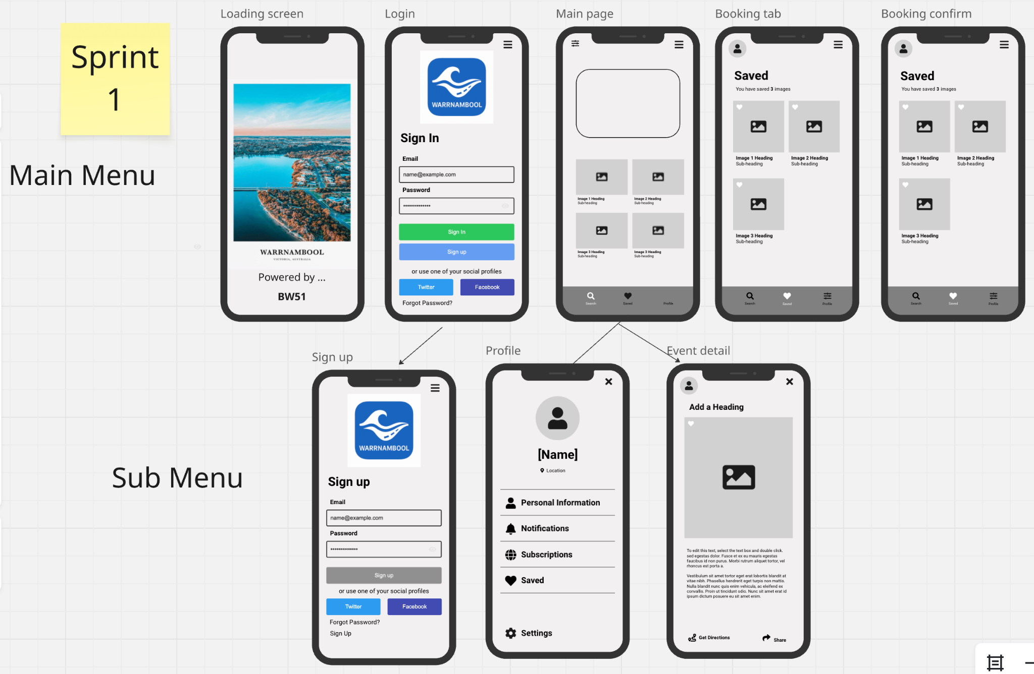

In Sprint 1, the team focused on understanding the Miro interface and exploring how to design basic mobile app layouts. A template was drafted to guide future development. This sprint served as the foundation for UI planning, user flow alignment, and learning how to visualise features before actual development. No functional screens were finalised, but the structure for future sprints was established.

#### **Sprint 2: Initial Prototype Based on User Stories**

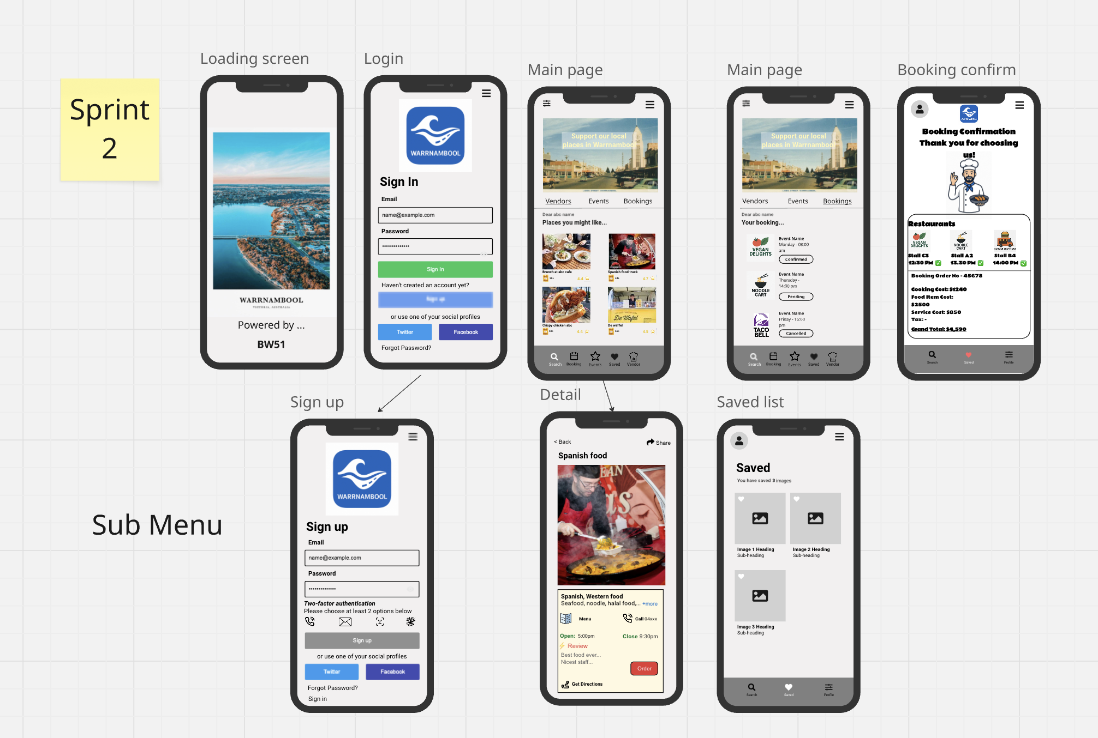

During Sprint 2, the first working prototype was designed based on our initial product backlog and MVP scope. Key components developed included:

* Loading screen with sponsor branding (Kermond’s Hamburgers)
* User authentication (Sign In and Sign Up)
* Two home interfaces: *Vendor Home* and *Event Home*
* Event and Vendor detail pages
* Booking flow: Event Ticket, Vendor Booking, Confirmation
* Saved favourites: Favourite Vendors and Favourite Events

These screens met the MVP for Sprint 2 and demonstrated an end-to-end user journey from sign-in to booking and confirmation.

#### **Sprint 3: Full App Draft Aligned with Stakeholder Expectations**

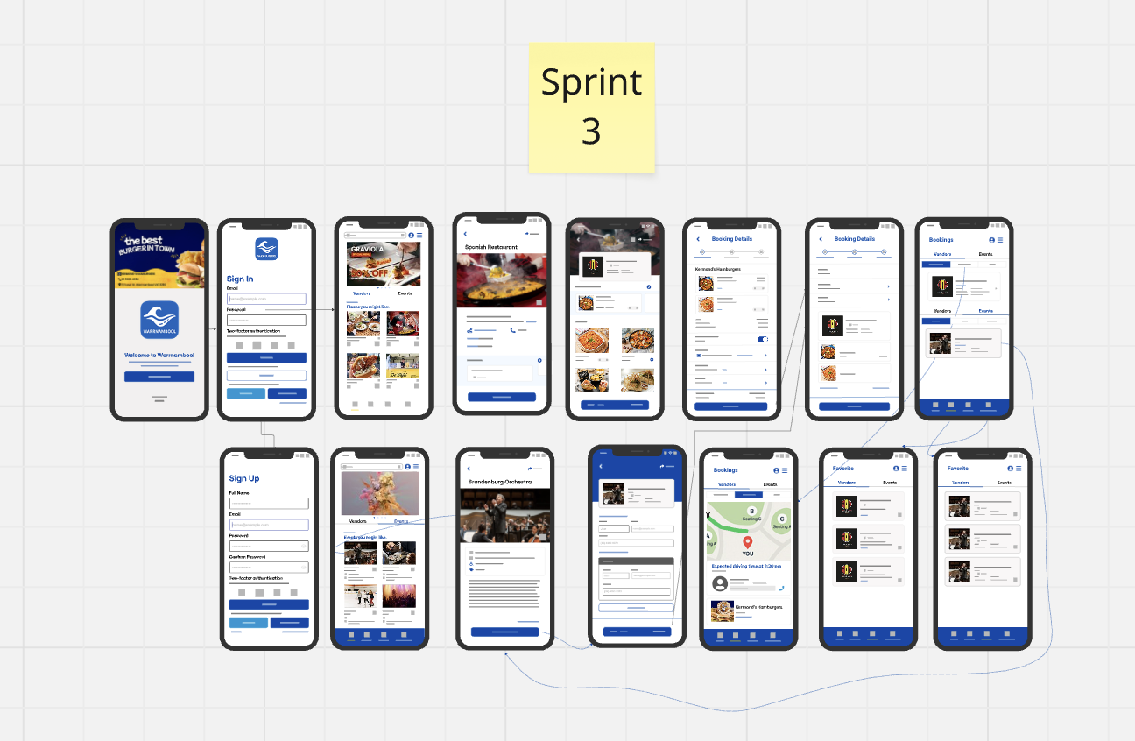

In Sprint 3, the app was expanded into a more functional and visually aligned prototype, incorporating detailed feedback from the client. New and refined features included:

* Vendor Menu interface and individual menu items
* Event ticketing system with interactive form fields
* Booking confirmation page with seat map and driving time estimates
* Booking history with tabs for Vendors and Events
* Improved navigation with a bottom menu bar
* Favourites and saved interactions for users

This sprint was critical in showcasing the app’s core services and preparing it for stakeholder presentation.

#### **Sprint 4: Expanded Role-Based Functionality (Admin, Event Organiser, Vendor)**

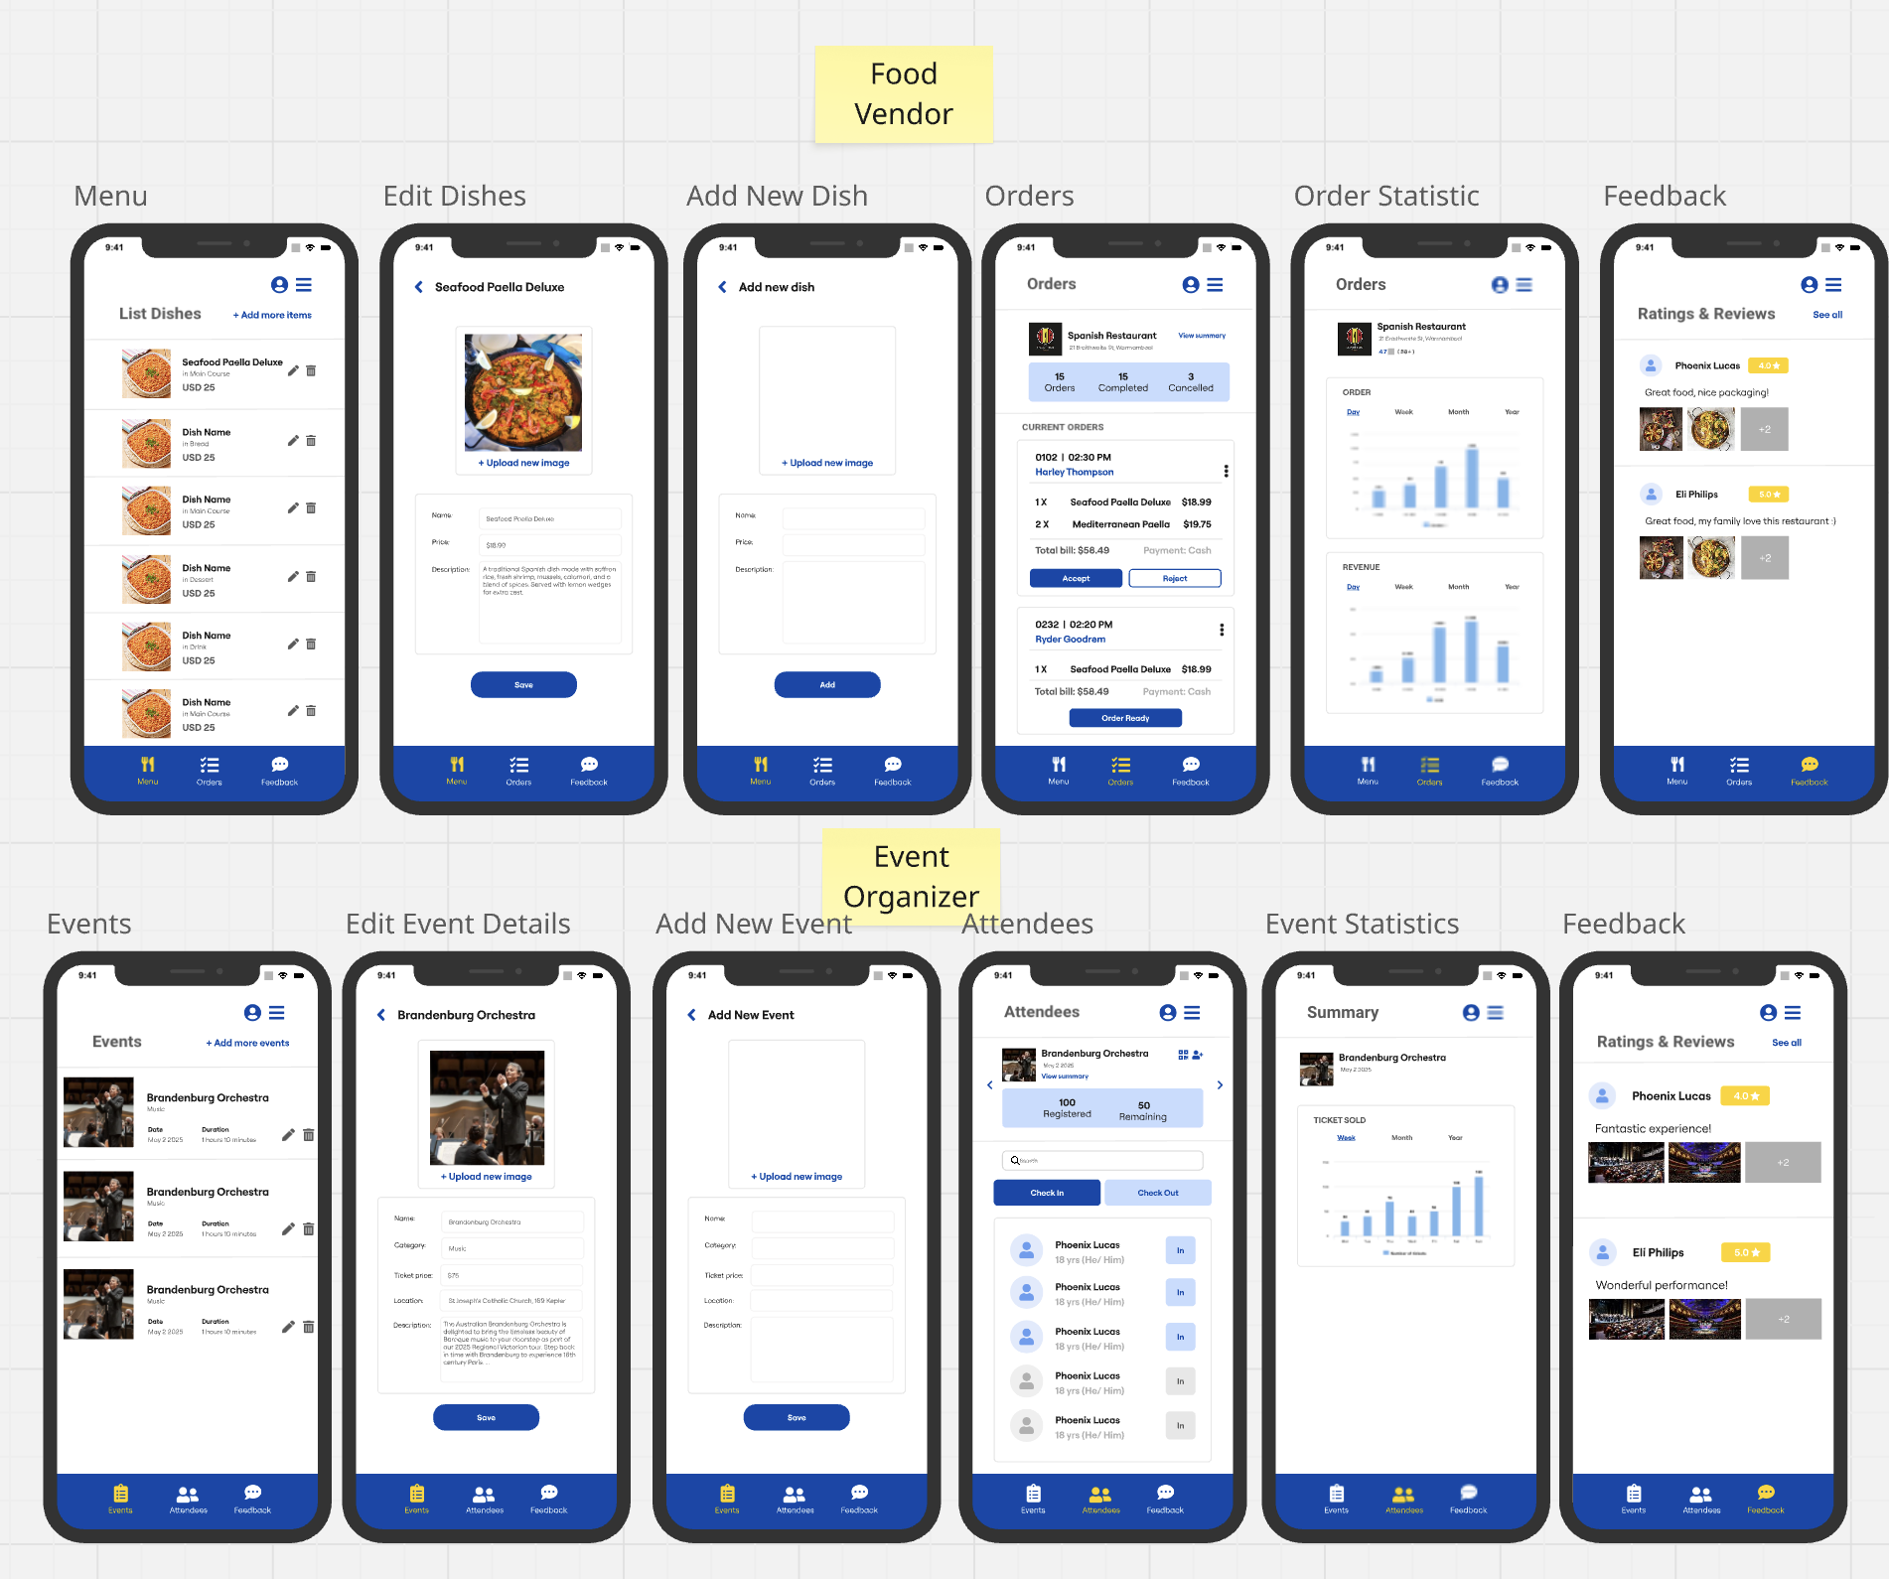

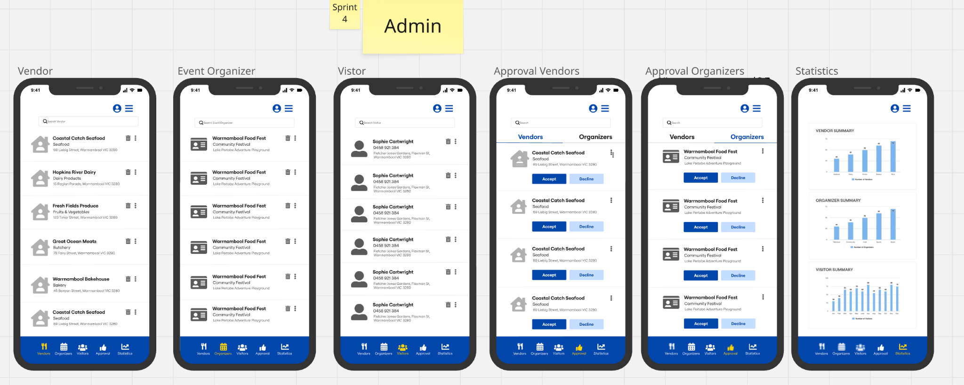

Sprint 4 introduced role-specific views, expanding the app's scalability and back-end control. Key features included:

**Admin Panel:**

* Vendor, organiser, and visitor management
* Approval workflows for vendors and organisers
* Real-time statistics dashboards for app usage and engagement

**Event Organiser Module:**

* Event creation and editing
* Attendee tracking with check-in/check-out features
* Event statistics visualised weekly, monthly, and yearly
* User feedback and event ratings

**Food Vendor Module:**

* Dish listing and editing
* New dish addition with image upload
* Order management and real-time status
* Customer ratings and reviews

These features allowed the app to function beyond just the customer side and supported event administration and vendor interaction.

#### **Sprint 5: Final Design Refinement for Client Presentation**

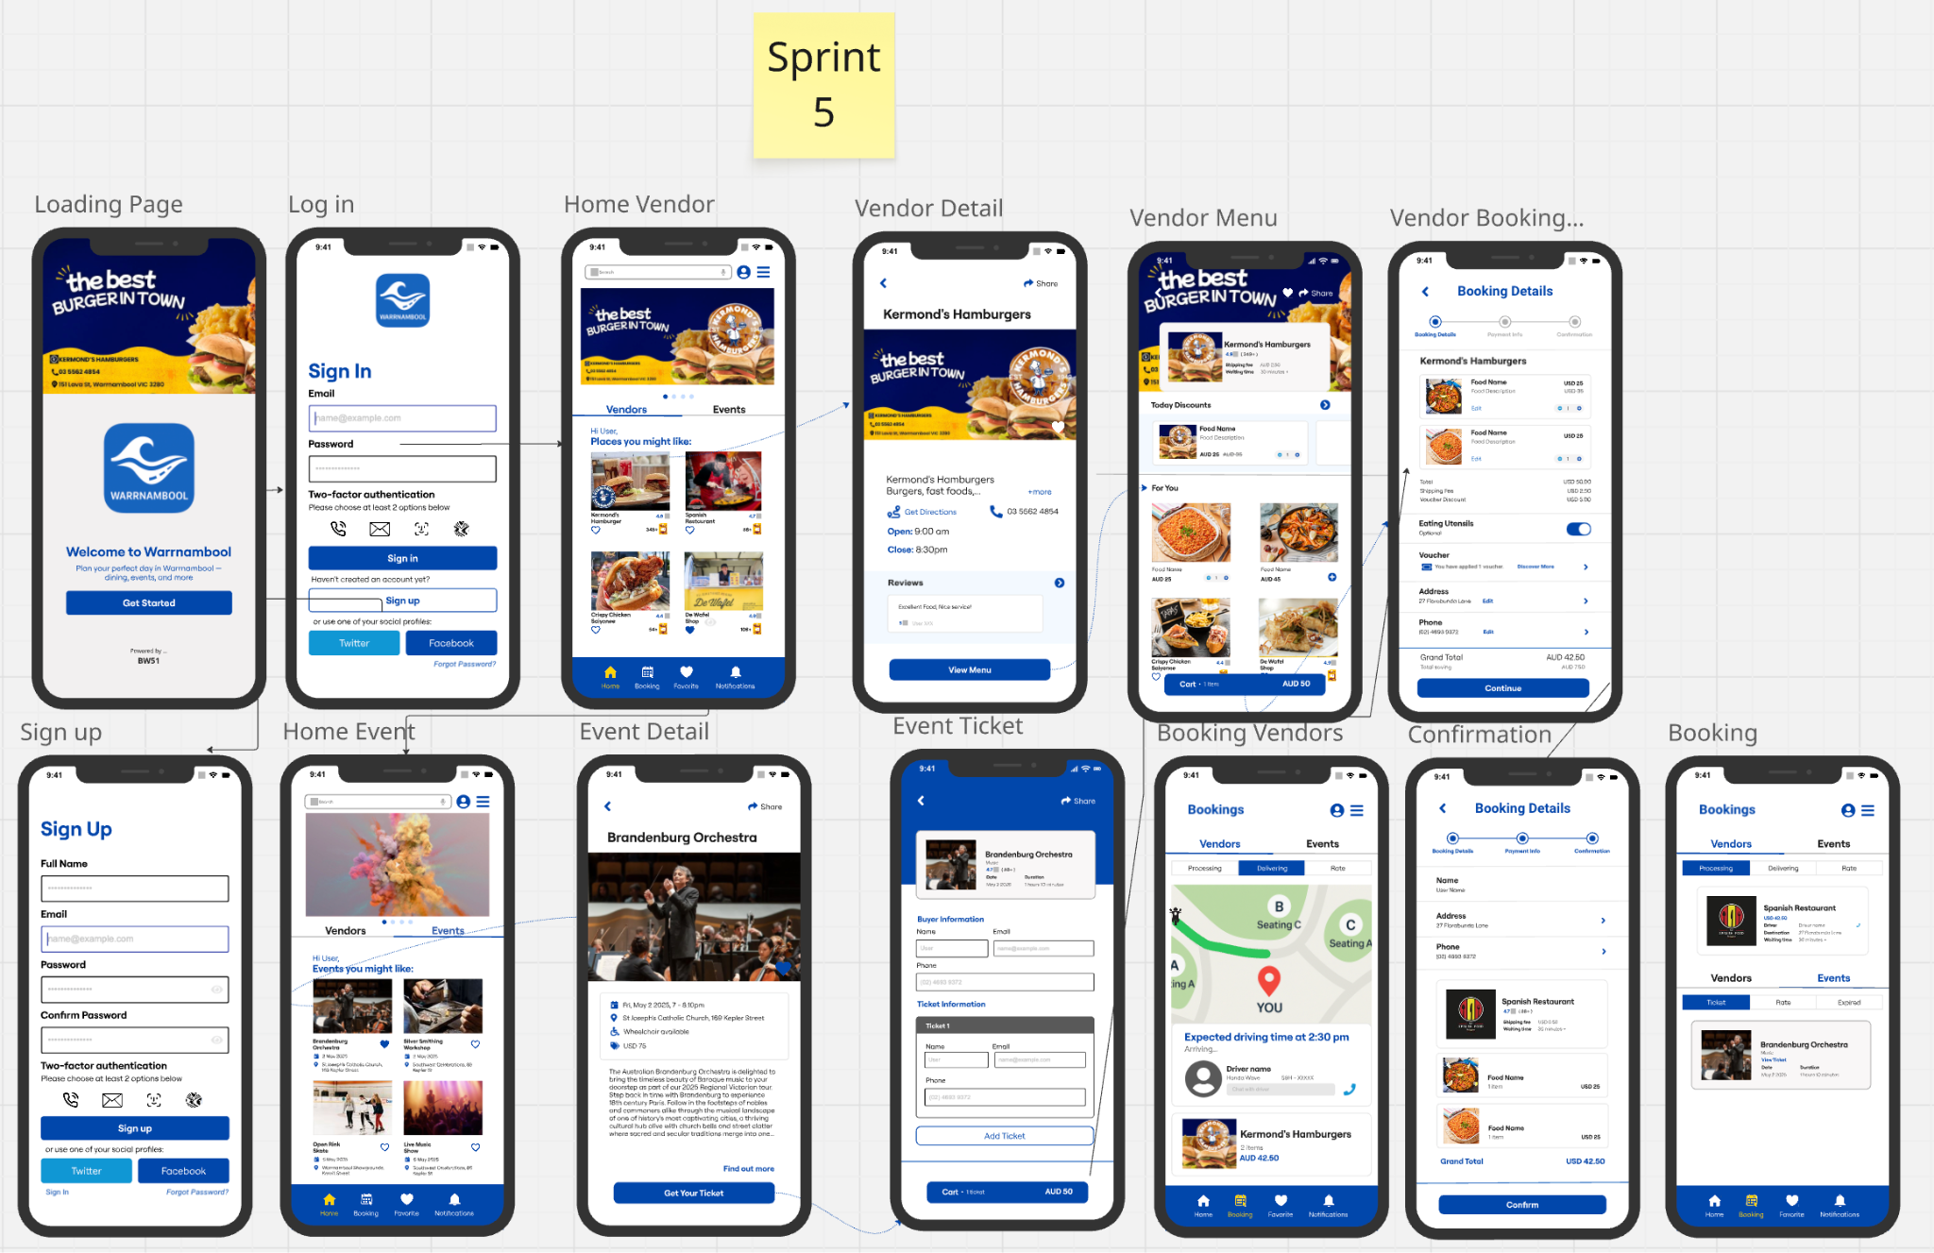

Sprint 5 focused on polishing the UI and integrating visual consistency across all modules. Adjustments were made to ensure that all content met the 3-click navigation rule. Sponsor visibility was optimised, making it easier for the Warrnambool Events Committee and our sponsor Kermond’s Hamburgers to understand how branding and business integration functioned in-app.

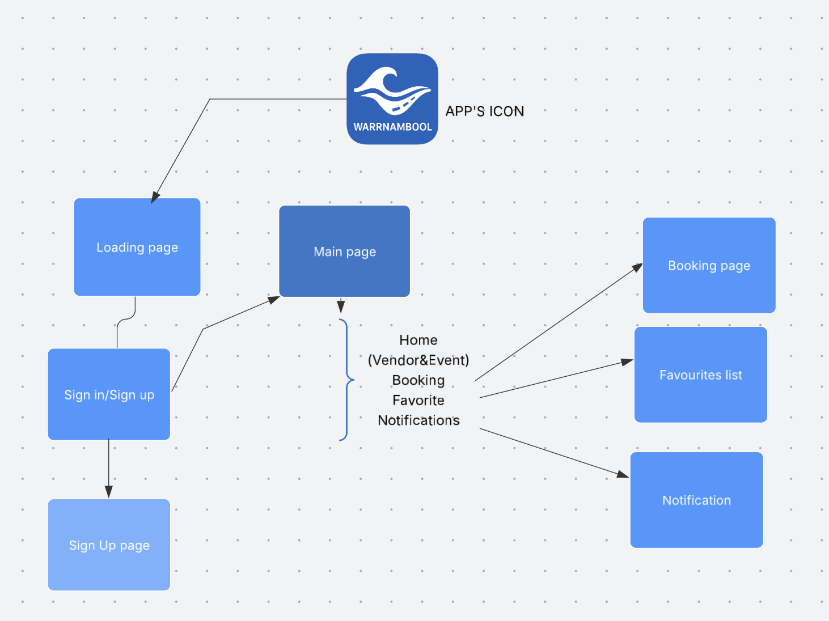

**Site-map for Warrnambool app.**

The final prototype reflected a complete, multi-role event catering platform ready for further development investment. The sitemap shows how users move through the app. It starts with a loading screen, then a login or sign-up page. Once logged in, users arrive at the main page.

From the main page, users can easily access food vendors, events, booking details, saved favourites, and notifications. Each section can be reached in three taps or less. This clear layout makes the app simple to use and helps users find what they need quickly.

The interface was created in Miro and designed for different roles: visitors, vendors, and admins. The final version includes sponsor ads, dashboard features, and a consistent look. All MVP goals across the five sprints were completed.

# 

# 

# **Appendix**

#### Sprint 1:

Stand-up Meetings:

MEETING MINUTES

| **Meeting/ Project Name:** | MIS398 - PROJECT MANAGEMENT (BW51) | | |
| --- | --- | --- | --- |
| **Date :**  **(MM/DD/YY)** | 10/04/2025 | **Time:** | 9PM – 9.15PM |
| **Minutes Prepared By :** | Le Duc Thinh Bui | **Location:** | MS Teams |

| 1.Agenda |
| --- |
| * Getting used to the Jira app, Miro app. * Ensure that everyone is understanding and progressing as planned. |

| **2.Attendees** | **Absences (with reason)** | **Absences (no reason)** | **S-number** |
| --- | --- | --- | --- |
| Le Duc Thinh Bui |  |  | 224529287 |
| LOVISH BANSAL |  |  | 223607238 |
| Tristan Farrell Budiman |  |  | 223944272 |
| Piyush Arora |  |  | 223625571 |
| Muhammad Rafi Azka |  |  | 223639248 |

| **3. MVP:**  A complete project setup with team communication plan, Stand-Up schedule, MIRO template, prioritised user stories on JIRA, and storage system for screenshots, documents, and notes in MS Teams. | | | | |
| --- | --- | --- | --- | --- |
| **4. Contents:**  **Name** | **What did you do yesterday?** | **What tasks are you currently working on?** | **What do you plan to do the next day?** | **What roadblocks are you facing as a group and as individuals?** |
| Le Duc Thinh Bui | Review Jira backlog and prepare meeting minutes for the next standup meeting | Getting used to the Jira website.  Create meeting minutes templates. | Prepare for the final meeting for sprint 1 - retrospective meeting, ask team members for their expectation for the mark, create a Miro template. | Finding template for the meeting minutes. |
| Muhammad Rafi Azka | Read the assignment description and prepared information for the next meeting. | I'm getting used to the MIRO app in order to start a basic app design for the app | I will create a basic layout in MIRO so that it can later be discussed. | ​​​​Finding relevant information in order to know what kind of features does the app need for the app design |
| Lovish Bansal | I watched online lecture on jira and its use cases | Create user stories. | I learned how to use miro | Not the moment |
| Piyush Arora | Learnt how to use Jira | Create user stories. | Complete the user stories on jira , before the deadline | Not at the moment |
| Tristan Farrell Budiman | Participating in the team meeting and contribute ideas in the meeting | Create user stories on Jira. | Complete assigned user stories on Jira before the agreed deadlines | No at the moment |
|  |  |  |  |  |
| Next meeting: 13th April, 2025 9pm-9.15pm | | | | |
|  | | | | |

**MEETING MINUTES**

| **Meeting/ Project Name:** | MIS398 - PROJECT MANAGEMENT (BW51) | | |
| --- | --- | --- | --- |
| **Date :**  **(MM/DD/YY)** | 23/04/2025 | **Time:** | 9PM – 9.15PM |
| **Minutes Prepared By :** | Le Duc Thinh Bui | **Location:** | MS Teams |

| 1.Agenda |
| --- |
| * Getting used to the Jira app, Miro app. * Ensure that everyone is understanding and progressing as planned. |

| **2.Attendees** | **Absences (with reason)** | **Absences (no reason)** | **S-number** |
| --- | --- | --- | --- |
| Le Duc Thinh Bui |  |  | 224529287 |
| LOVISH BANSAL |  |  | 223607238 |
| Tristan Farrell Budiman |  |  | 223944272 |
| Piyush Arora |  |  | 223625571 |
| Muhammad Rafi Azka |  |  | 223639248 |

| **3. MVP:**   A complete project setup with team communication plan, Stand-Up schedule, MIRO template, prioritised user stories on JIRA, and storage system for screenshots, documents, and notes in MS Teams. | | | | |
| --- | --- | --- | --- | --- |
| **4. Contents:**  **Name** | **What did you do yesterday?** | **What tasks are you currently working on?** | **What do you plan to do the next day?** | **What roadblocks are you facing as a group and as individuals?** |
| Le Duc Thinh Bui | Getting used to the Jira website.  Created meeting minutes templates.  Created Miro app template, completed user stories. | Organise all the documents, files relevant to this project. | Prepare for the final meeting for sprint 1 - retrospective meeting, check up everyday with other progress. | Team communication needs to be more effective, as everyone responds too late. |
| Muhammad Rafi Azka | I'm getting used to the MIRO app in order to start a basic app design for the app. | I'm getting used to the MIRO app in order to start a basic app design for the app. | I will create a basic layout in MIRO so that it can later be discussed. | ​​​​Finding relevant information in order to know what kind of features does the app need for the app design |
| Lovish Bansal | I completed the user stories. | Create user stories. | I learned how to use miro. | Not the moment |
| Piyush Arora | I completed the user stories. | I uploaded the user stories in done section. | Prepare for the next sprint. | Not at the moment |
| Tristan Farrell Budiman | Implement of my understanding by using Jira, and completing my user stories | Create user stories on Jira. | Complete assigned user stories on Jira. | No at the moment |
| Next meeting: 13th April, 2025 9pm-9.15pm | | | | |

#### Sprint 2:

Stand-Up Meetings:

**MEETING MINUTES**

| **Meeting/ Project Name:** | MIS398 - PROJECT MANAGEMENT (BW51) | | |
| --- | --- | --- | --- |
| **Date :**  **(MM/DD/YY)** | 17/04/2025 | **Time:** | 6:30PM – 6:40PM |
| **Minutes Prepared By :** | Le Duc Thinh Bui | **Location:** | MS Teams |

| **1.Agenda:**   * Finalise application’s logo, application’s name * Catching up with the team |
| --- |

| **2.Attendees** | **Absences (with reason)** | **Absences (no reason)** | **S-number** |
| --- | --- | --- | --- |
| Le Duc Thinh Bui |  |  | 224529287 |
| LOVISH BANSAL |  |  | 223607238 |
| Tristan Farrell Budiman |  |  | 223944272 |
| Piyush Arora |  |  | 223625571 |
| Muhammad Rafi Azka | sick |  | 223639248 |

| **3.MVP:**  MVP - The Minimum Viable Product for Sprint 2 involved creating a prototype featuring a splash screen with the festival logo, a main menu navigation screen, at least two sub-menus highlighting essential festival categories, and at least one content page. | | | | |
| --- | --- | --- | --- | --- |
| Name | What did you do yesterday? | What tasks are you currently working on? | What do you plan to do the next day? | What roadblocks are you facing as a group and as individuals? |
| Le Duc Thinh Bui | Creating user stories for logging page as an admin | Creating user stories for the app | Finalise user stories and create features which gonna be in the app | No |
| LOVISH BANSAL | creating user stories around main page as an visitor | scaling the tasks according to the mvp for the following sprint | start to add features in miro according to user stories in main page as a visitor | no |
| Tristan Farrell Budiman | creating user stories around booking confirmation page as an event organizer | creating user stories for the app on miro | do some finalization on the app page (e.g elements and logos) in booking confirmation page | No |
| Piyush Arora | creating user stories around main page as an visitor | Creating user stories for the app | started making app according to the user stories | No |
| Muhammad Rafi Azka | create user stories around the food vendor | making the design for the booking tab | finalizing the design of the booking tab for the app and ensuring it aligns with the user stories in the sprint | No |
| Next meeting: 23th April, 2025 9pm-9.15pm | | | | |

**MEETING MINUTES**

| **Meeting/ Project Name:** | MIS398 - PROJECT MANAGEMENT (BW51) | | |
| --- | --- | --- | --- |
| **Date :**  **(MM/DD/YY)** | 23/04/2025 | **Time:** | 9PM – 9.15PM |
| **Minutes Prepared By :** | Le Duc Thinh Bui | **Location:** | MS Teams |

| **1.Agenda**   * Review the app design based on user stories. * Ensure that everyone is aligned and progressing as planned. |
| --- |

| **2.Attendees** | **Absences (with reason)** | **Absences (no reason)** | **S-number** |
| --- | --- | --- | --- |
| Le Duc Thinh Bui |  |  | 224529287 |
| LOVISH BANSAL |  |  | 223607238 |
| Tristan Farrell Budiman |  |  | 223944272 |
| Piyush Arora |  |  | 223625571 |
| Muhammad Rafi Azka |  |  | 223639248 |

| **3.MVP:**  MVP - The Minimum Viable Product for Sprint 2 involved creating a prototype featuring a splash screen with the festival logo, a main menu navigation screen, at least two sub-menus highlighting essential festival categories, and at least one content page. | | | | |
| --- | --- | --- | --- | --- |
| **Name** | **What did you do yesterday?** | **What tasks are you currently working on?** | **What do you plan to do the next day?** | **What roadblocks are you facing as a group and as individuals?** |
| Le Duc Thinh Bui | Designed the login page and loading page. | Designing the app. | Complete the app design | Too many functions to design. |
| Tristan Farrell Budiman | Designed the booking confirmation | Finalizing and refinish the app | reviewing the app with team members about what should or should not be edited / remove and completing the app ui design | none |
| Piyush Arora | designed the main page | finalizing the app | review the app with team members | None |
| Muhammad Rafi Azka | finalizing booking tab and other pages for the food vendor section | finalizing the design and check if it satisfy the user stories in the sprint | discussing the app design with team members to ensure its finalization | None |
| Lovish bansal | designed the main page on miro | checking that all the user stories are covered | discussing with the team around the main page ui | none |
| Next meeting: 24th April, 2025 9pm-9.15pm | | | | |

Retrospective meeting:

**MEETING MINUTES**

| **Meeting/ Project Name:** | MIS398 - PROJECT MANAGEMENT (BW53) | | |
| --- | --- | --- | --- |
| **Date :**  **(MM/DD/YY)** | 25/04/2025 | **Time:** | 9pm-9.20pm |
| **Minutes Prepared By :** | Thinh | **Location:** | Team meeting |

| **1.Agenda**   * Review and evaluate the team’s performance during Sprint 2. * Identify key success and areas requiring improvement. * Establish actionable strategies to strengthen collaboration and optimise efficiency in future sprints. |
| --- |

| **2.Attendees** | **Absences (with reason)** | **Absences (no reason)** | **S-number** |
| --- | --- | --- | --- |
| Le Duc Thinh Bui |  |  | s224529287 |
| Tristan Farrell Budiman |  |  | s223944272 |
| Piyush Arora |  |  | s223625571 |
| Muhammad Rafi Azka |  |  | s223639248 |
| Lovish bansal |  |  | s223607238 |

| **3.Content** |  |  |  |  |  |
| --- | --- | --- | --- | --- | --- |
| **Member** | **What worked well?** | **What didn’t work?** | **What needs improvement?** | **What would you like to repeat?** | **Team Collaborations** |
| Lovish Bansal | everyone knows what they are doing in this unit | sharing task | clarity around creating user stories around the sprint discussion | nothing in particular | Getting to know each other and improvise our communication for the future |
| Le Duc Thinh Bui | Having 3 meetings a week and all attended | The user stories are sometimes just too overall, and should be narrowed. | Everyone should be more proactive when doing their tasks | Team meeting | Communicating on MS team got better. |
| Muhammad Rafi Azka | finishing our task on time as a team | Task distribution and decision making | Groups discussion and decision making as a group | Task completion rate | Communication was active even though there was an issue with user story clarity |
| Tristan Farrell Budiman | -Communication works very well on each team member  - Finish on our task on time  - Meetings works well | Task distribution | Discussion with each team member needs to be improvised | -Team meetings  - Task completion | Build up communication and teamwork towards next task that we have to do together |
| Piyush Arora | Great team work , finishing the task on time. | Task distribution and decision making | Need more creativity while doing their task | Team meeting | Communication works well with each team members |
| **Next Stand-up Meeting sprint 3**: 28th April | | | | | |

#### Sprint 3:

Stand-Up Meetings:

**MEETING MINUTES**

| **Meeting/ Project Name:** | MIS398 - PROJECT MANAGEMENT (BW51) | | |
| --- | --- | --- | --- |
| **Date :**  **(MM/DD/YY)** | 28/04/2025 | **Time:** | 9PM – 9.15PM |
| **Minutes Prepared By :** | Le Duc Thinh Bui | **Location:** | MS Teams |

| **1.Agenda**   * Review the app design based on user stories. * Ensure that everyone is aligned and progressing as planned. * What tasks were completed since the last meeting? * What tasks are currently in progress? * Are there any blockers (e.g. unclear requirements, technical issues)? * Confirm progress on high-priority features (e.g. ticketing, food ordering, emergency info) |
| --- |

| **2.Attendees** | **Absences (with reason)** | **Absences (no reason)** | **S-number** |
| --- | --- | --- | --- |
| Le Duc Thinh Bui |  |  | 224529287 |
| LOVISH BANSAL |  |  | 223607238 |
| Tristan Farrell Budiman |  |  | 223944272 |
| Piyush Arora |  |  | 223625571 |
| Muhammad Rafi Azka |  |  | 223639248 |

| **3.MVP:**  MVP - The Minimum Viable Product for Sprint 3 involved creating a prototype that meet the product owner requirement - An app for the local **Event Food Catering** outlets, takeaway shop information, location sites reserve bookings: Online customer food ordering for customers. | | | | |
| --- | --- | --- | --- | --- |
| **Name** | **What did you do yesterday?** | **What tasks are you currently working on?** | **What do you plan to do the next day?** | **What roadblocks are you facing as a group and as individuals?** |
| Le Duc Thinh Bui | Checked if we were on the right track with Emma | Design pages for the app | Complete designing the app to meet the MVP | No |
| Muhammad Rafi Azka | Finding relevant information to design the app for food vendor | Drafting the design for the app | Creating the app design to satisfy the user stories for food vendor | No |
| Lovish Bansal | finding user stories around visitor for sprint 3 | applying user stories on miro | discussing with team about the prograss | no |
| Piyush Arora | finding user stories around visitor to design the app | design pages on the miro | taking feedback from the team about the app design | No |
| Tristan Farrell Budiman | creating user stories for sprint 3 and getting information for the UI for miro | designing our miro app | meeting with the team and discuss further about what we’re going to do on next task and completing our design on the app | No |
| Next meeting: 30th April, 2025 9pm-9.15pm | | | | |

**MEETING MINUTES**

| **Meeting/ Project Name:** | MIS398 - PROJECT MANAGEMENT (BW51) | | |
| --- | --- | --- | --- |
| **Date :**  **(MM/DD/YY)** | 30/04/2025 | **Time:** | 9PM – 9.15PM |
| **Minutes Prepared By :** | Le Duc Thinh Bui | **Location:** | MS Teams |

| **1.Agenda**   * Review the app design based on user stories. * Ensure that everyone is aligned and progressing as planned. * Quick update on each team member's current task * Identify tasks that are behind or need support * Check if story point estimates match actual effort * Discuss if any scope adjustments are needed * Confirm next 24-hour goals and collaboration needs |
| --- |

| **2.Attendees** | **Absences (with reason)** | **Absences (no reason)** | **S-number** |
| --- | --- | --- | --- |
| Le Duc Thinh Bui |  |  | 224529287 |
| LOVISH BANSAL |  |  | 223607238 |
| Tristan Farrell Budiman |  |  | 223944272 |
| Piyush Arora |  |  | 223625571 |
| Muhammad Rafi Azka |  |  | 223639248 |

| **3.MVP:**  MVP - The Minimum Viable Product for Sprint 3 involved creating a prototype that meet the product owner requirement - An app for the local **Event Food Catering** outlets, takeaway shop information, location sites reserve bookings: Online customer food ordering for customers. | | | | |
| --- | --- | --- | --- | --- |
| **Name** | **What did you do yesterday?** | **What tasks are you currently working on?** | **What do you plan to do the next day?** | **What roadblocks are you facing as a group and as individuals?** |
| Le Duc Thinh Bui | Completed the template design for the app based on the user stories. | Completing the app interface for admin users. | Completing app’s look and organising documents. | Team members weren't active during the holidays break. |
| Muhammad Rafi Azka | Creating the app design | Finalizing the app design for food vendor | Cross-checking with my team to see if the design is good and can satisfy the user stories | No |
| Piyush Arora | Creating the app design | Done with app design for a visitor | Reviewing the app with team members | No |
| Lovish Bansal | Creating app design | Reviewing that app is being made according to user stories | Discussing with teammates about the progress | no |
| Tristan Farrell Budiman | Creating app design | Review + finalizing the app for event organizer | Discussing with the team on the UI design | No |
| Next meeting: 2nd May, 2025 9pm-9.15pm | | | | |

Retrospective meeting:

**MEETING MINUTES**

| **Meeting/ Project Name:** | MIS398 - PROJECT MANAGEMENT (BW53) | | |
| --- | --- | --- | --- |
| **Date :**  **(MM/DD/YY)** | 05/02/2025 | **Time:** | 3:30 PM - 04:05 PM |
| **Minutes Prepared By :** | Tristan | **Location:** | Class |

| **1.Agenda**   * Review and evaluate the team’s performance during Sprint 3. * Identify key success and areas requiring improvement. * Establish actionable strategies to strengthen collaboration and optimise efficiency in future sprints. |
| --- |

| **2.Attendees** | **Absences (with reason)** | **Absences (no reason)** | **S-number** |
| --- | --- | --- | --- |
| Le Duc Thinh Bui |  |  | s224529287 |
| Tristan Farrell Budiman |  |  | s223944272 |
| Piyush Arora |  |  | s223625571 |
| Muhammad Rafi Azka |  |  | s223639248 |
| Lovish Bansal |  |  | s223607238 |

**3.Content**

| **Member** | **What worked well?** | **What didn’t work?** | **What needs improvement?** | **What would you like to repeat?** | **Team Collaborations** |
| --- | --- | --- | --- | --- | --- |
| Lovish Bansal | communication with team peers | got stuck at making burndown chart properly | development of app on miro according to user stories (more specific) | making of app for sprint 3 | communication within each team member improved throughout each day |
| Le Duc Thinh Bui | Prototype design was completed on time. Met the MVP expectations. | The burndown chart failed as one team member tried to fix the story points. | Team communication and contribution, each team member must be more active on their task | User stories were great.  Team members should attend on time. | In sprint 3, everyone was mainly communicating through the unofficial Whatsapp app, should mainly communicating on MS team instead. |
| Muhammad Rafi Azka | sprint completion as a team and group communication | Burntdown chart and Time management | working as a team | user stories completion and how the work was divided | Moral and team collaboration were high and communication improved from the previous sprint |
| Tristan Farrell Budiman | Communication works very well and improving with each team members | burndown chart and time efficiency | time management for doing our tasks | - keeping our communications well with team members  - maintain a good work on running the task each team members | Helping each other if any of the team members experienced difficulties, communications between each team members improved. |
| Piyush Arora | communication worked very well | Burndown chart was not up to mark | More involvement from team members | doing tasks on time | communication improve with team members (offline or online) |

#### Sprint 4:

Stand-Up Meeting:

**MEETING MINUTES**

| **Meeting/ Project Name:** | MIS398 - PROJECT MANAGEMENT (BW51) | | |
| --- | --- | --- | --- |
| **Date :**  **(MM/DD/YY)** | 3/05/2025 | **Time:** | 9PM – 9.15PM |
| **Minutes Prepared By :** | Le Duc Thinh Bui | **Location:** | MS Teams |

| **1.Agenda** |
| --- |
| * Review the app design based on user stories. * Ensure that everyone is aligned and progressing as planned. |

| **2. Attendees** | **Absences (with reason)** | **Absences (no reason)** | **S-number** |
| --- | --- | --- | --- |
| Le Duc Thinh Bui |  |  | 224529287 |
| LOVISH BANSAL |  |  | 223607238 |
| Tristan Farrell Budiman |  |  | 223944272 |
| Piyush Arora |  |  | 223625571 |
| Muhammad Rafi Azka |  |  | 223639248 |

| **3. MVP:**  MVP - The Minimum Viable Product for Sprint 4 involved creating a prototype that meet the product owner requirement - An app for the local **Event Food Catering** outlets, takeaway shop information, location sites reserve bookings: Online customer food ordering for customers. | | | | |
| --- | --- | --- | --- | --- |
| **Name** | **What did you do yesterday?** | **What tasks are you currently working on?** | **What do you plan to do the next day?** | **What roadblocks are you facing as a group and as individuals?** |
| Le Duc Thinh Bui | Had a meeting with other group product owners to discuss the product design. | Completing UI design. | Finalise the app interface. | No |
| Muhammad Rafi Azka | Making sure about the template for the app design | creating user stories  for food vendor | finalizing the user stories and start creating the wireframe for the app | No |
| Lovish Bansal | Designing the template for visitor | creating user stories as a visitor | started creating the wireframe for the app | no |
| Piyush Arora | done meeting with the team designed the template as visitor | creating user stories as a visitor | Finalise the app user stories and creating the app interface | No |
| Tristan Farrell Budiman | Designing the template for Event Organizer Tab | completing ui design , creating user stories for Event organziner | finalizing user stories and creating the app interface so that it looks good | No |
| Next meeting: 5 May, 2025 9pm-9.15pm | | | | |

**MEETING MINUTES**

| **Meeting/ Project Name:** | MIS398 - PROJECT MANAGEMENT (BW51) | | |
| --- | --- | --- | --- |
| **Date :**  **(MM/DD/YY)** | 05/05/2025 | **Time:** | 9PM – 9.15PM |
| **Minutes Prepared By :** | Le Duc Thinh Bui | **Location:** | MS Teams |

| 1. **Agenda** |
| --- |
| * Review the app design based on user stories. * Ensure that everyone is aligned and progressing as planned. |

| 1. **Attendees** | **Absences (with reason)** | **Absences (no reason)** | **S-number** |
| --- | --- | --- | --- |
| Le Duc Thinh Bui |  |  | 224529287 |
| LOVISH BANSAL |  |  | 223607238 |
| Tristan Farrell Budiman |  |  | 223944272 |
| Piyush Arora |  |  | 223625571 |
| Muhammad Rafi Azka |  |  | 223639248 |

| 1. **MVP:**  MVP - The Minimum Viable Product for Sprint 4 involved creating a prototype that meet the product owner requirement - An app for the local **Event Food Catering** outlets, takeaway shop information, location sites reserve bookings: Online customer food ordering for customers. | | | | |
| --- | --- | --- | --- | --- |
| **Name** | **What did you do yesterday?** | **What tasks are you currently working on?** | **What do you plan to do the next day?** | **What roadblocks are you facing as a group and as individuals?** |
| Le Duc Thinh Bui | Had a meeting with other group product owners to discuss product design. | Completing UI design. | Finalise the app interface. | No |
| Muhammad Rafi Azka | Discussing with the team about the user stories that needs to be created and creating it | Making the wireframe for Food vendor | continue progress on the wireframe creation | No |
| Lovish Bansal | Discussing with the team about the user stories | Making the wireframe for visitor | Finalise the app UI design | no |
| Piyush Arora | meeting with the team members and discussed about user stories | completing the UI design | Finalise the app UI design | No |
| Tristan Farrell Budiman | Did a meeting with teams and discussing user stories that should be made | - Making the wireframe for Event Organizer  - Developing UI Design | Finalise the app UI design | No |
| Next meeting: 7 May, 2025 9pm-9.15pm | | | | |

Retrospective Meeting:

**MEETING MINUTES**

| **Meeting/ Project Name:** | MIS398 - PROJECT MANAGEMENT (BW53) | | |
| --- | --- | --- | --- |
| **Date :**  **(MM/DD/YY)** | 10/05/2025 | **Time:** | 9pm-9.30pm |
| **Minutes Prepared By :** | Thinh | **Location:** | Team meeting |

| **1.Agenda**   * Review and evaluate the team’s performance during Sprint 4. * Identify key success and areas requiring improvement. * Establish actionable strategies to strengthen collaboration and optimise efficiency in future sprints. |
| --- |

| **2.Attendees** | **Absences (with reason)** | **Absences (no reason)** | **S-number** |
| --- | --- | --- | --- |
| Le Duc Thinh Bui |  |  | s224529287 |
| Tristan Farrell Budiman |  |  | s223944272 |
| Piyush Arora |  |  | s223625571 |
| Muhammad Rafi Azka |  |  | s223639248 |
| lovish bansal |  |  | s223607238 |

**3. Content**

| **Member** | **What worked well?** | **What didn’t work?** | **What needs improvement?** | **What would you like to repeat?** | **Team Collaborations** |
| --- | --- | --- | --- | --- | --- |
| Lovish Bansal | as we thought of your app layout , it just looks like that | inconsistency in communication , as everyone is busy in other assignments | completion of tasks as decided on that date | team should be more active while attending meeting | team should discuss about the difficulties they are facing so other , can help to resolve that |
| Le Duc Thinh Bui | The prototype was completed as planned | Toward the end, members became fatigued and overwhelmed by other assignments, which affected the quality of work in Sprint | Team members need to stay more engaged with their assigned tasks, and the overall quality of work should be improved. | The group should maintain consistent engagement throughout the entire sprint. | If unsure about any task, team members should proactively ask questions to clarify and avoid misunderstandings. |
| Muhammad Rafi Azka | Completed the app and the user stories that was assigned to each group member were completed | inconsistency in communication and engagement between the group | Communication to avoid any misunderstanding | Consistency of user stories completion and Work distribution between the group members | If the task is not completed but can still be completed before the closing of the sprint team members should ask for help to other members so that the task could be completed |
| Tristan Farrell Budiman | Completed the app and user stories | communication problem , group member busy with their own assignments which leads to unfocused on doing the assignment work | Communication needs to be improved along the work | Engagement while meeting and consistent while making user stories and doing all of the work | Ask with each team member to discuss about something that we didn’t understand to avoid misleading work |
| Piyush Arora | Completed the app and user stories | communication problem, all members busy because of other assignments. | team work , time management | team engagement while the team meeting | each member should discuss their problems , to avoid misleading work |
| **Next Meeting sprint 5**: 12th May | | | | | |

#### Sprint 5:

Stand-Up Meetings: **MEETING MINUTES**

| **Meeting/ Project Name:** | MIS398 - PROJECT MANAGEMENT (BW51) | | |
| --- | --- | --- | --- |
| **Date :**  **(MM/DD/YY)** | 12/05/2025 | **Time:** | 9PM – 9.15PM |
| **Minutes Prepared By :** | Le Duc Thinh Bui | **Location:** | MS Teams |

| **1.Agenda** |
| --- |
| * Progress updates on sponsor advertisement pages * Check integration of 3-click navigation rule * Review site-map draft and link placement in report * Identify any blockers for final feature implementation |

| **2. Attendees** | **Absences (with reason)** | **Absences (no reason)** | **S-number** |
| --- | --- | --- | --- |
| Le Duc Thinh Bui |  |  | 224529287 |
| LOVISH BANSAL |  | No | 223607238 |
| Tristan Farrell Budiman |  |  | 223944272 |
| Piyush Arora |  | - | 223625571 |
| Muhammad Rafi Azka |  |  | 223639248 |

| **3. MVP:**  A completed app prototype that integrates sponsor advertisements, includes a 3-click site navigation structure, and is supported by a finalised site-map (linked in the MVP section and added to the appendix). The final team report and recorded presentation (PowerPoint or Panopto) must also be prepared and ready for submission. | | | | |
| --- | --- | --- | --- | --- |
| **Name** | **What did you do yesterday?** | **What tasks are you currently working on?** | **What do you plan to do the next day?** | **What roadblocks are you facing as a group and as individuals?** |
| Le Duc Thinh Bui | Doublechecked all the information in those previous meeting minutes, and completed my user stories. | Organising all the documents we have from the start to now. | Preparing the final report and presentation with others members.  Completing the prototype. | No. |
| Muhammad Rafi Azka | Completing the user stories and start writing my part of the report | progressing on the report creation | Finalizing my part of the report and start doing the presentation part | None |
| Lovish Bansal |  |  |  |  |
| Piyush Arora |  |  |  |  |
| Tristan Farrell Budiman | Making the presentation for the final | Doing the presentation slides | Finalizing the slides for recording purposes | None |
| Next meeting: 15 May, 2025 OFFLINE ON LEVEL 4, LC BUILDING | | | | |

**MEETING MINUTES**

| **Meeting/ Project Name:** | MIS398 - PROJECT MANAGEMENT (BW51) | | |
| --- | --- | --- | --- |
| **Date :**  **(MM/DD/YY)** | 15/05/2025 | **Time:** | 2PM – 4PM |
| **Minutes Prepared By :** | Le Duc Thinh Bui | **Location:** | Level 4, LC Building |

| **1.Agenda** |
| --- |
| * Progress updates on sponsor advertisement pages * Check integration of 3-click navigation rule * Review site-map draft and link placement in report * Identify any blockers for final feature implementation |

| **2. Attendees** | **Absences (with reason)** | **Absences (no reason)** | **S-number** |
| --- | --- | --- | --- |
| Le Duc Thinh Bui |  |  | 224529287 |
| LOVISH BANSAL | License test |  | 223607238 |
| Tristan Farrell Budiman |  |  | 223944272 |
| Piyush Arora | Missed message |  | 223625571 |
| Muhammad Rafi Azka |  |  | 223639248 |

| **3. MVP:**  A completed app prototype that integrates sponsor advertisements, includes a 3-click site navigation structure, and is supported by a finalised site-map (linked in the MVP section and added to the appendix). The final team report and recorded presentation (PowerPoint or Panopto) must also be prepared and ready for submission. | | | | |
| --- | --- | --- | --- | --- |
| **Name** | **What did you do yesterday?** | **What tasks are you currently working on?** | **What do you plan to do the next day?** | **What roadblocks are you facing as a group and as individuals?** |
| Le Duc Thinh Bui | Organised all the documents and prepared a prototype to meet the stakeholders expectation. | Modifying the prototype design and catching up with other member tasks. | Presenting our draft in the practical class. | No. |
| Muhammad Rafi Azka | Finishing the report on the Teamwork and Retrospective meeting part | Editing and finalizing my part of the report | Making a script for the presentation in order to be prepared | None |
| Lovish Bansal |  |  |  |  |
| Piyush Arora |  |  |  |  |
| Tristan Farrell Budiman | Organising all documents that we need for making the report and presentation | Editing the presentation | Creating the presentation slides (draft) for the team | None |
| Next meeting: 16th May, 2025 OFFLINE IN LB BUILDING | | | | |

Retrospective Meeting:

**MEETING MINUTES**

| **Meeting/ Project Name:** | MIS398 - PROJECT MANAGEMENT (BW53) | | |
| --- | --- | --- | --- |
| **Date :**  **(MM/DD/YY)** | 16/05/2025 | **Time:** | 3pm-4.30pm |
| **Minutes Prepared By :** | Thinh | **Location:** | Team meeting |

| **1.Agenda**   * Review and evaluate the team’s performance during Sprint 5. * Identify key success and areas requiring improvement. * Establish actionable strategies to strengthen collaboration and optimise efficiency in future sprints. |
| --- |

| **2.Attendees** | **Absences (with reason)** | **Absences (no reason)** | **S-number** |
| --- | --- | --- | --- |
| Le Duc Thinh Bui |  |  | s224529287 |
| Tristan Farrell Budiman |  |  | s223944272 |
| Piyush Arora |  |  | s223625571 |
| Muhammad Rafi Azka |  |  | s223639248 |
| lovish bansal |  |  | s223607238 |

**3. Content**

| **Member** | **What worked well?** | **What didn’t work?** | **What needs improvement?** | **What would you like to repeat?** | **Team Collaborations** |
| --- | --- | --- | --- | --- | --- |
| Lovish Bansal | distribution of report and presentation | Sprint 5 burndown chart was not up to mark. | Review each other work and time management for each group member | Team members showing more involvement day by day | unofficial meetings , chats on whatsapp has helped alot in conducting meetings and resolving issues. |
| Le Duc Thinh Bui | Team members proactively reach out for help and help each other. | Sprint 5 burndown chart should be more consistently go down. | Scrum team members should be more independent to work with their tasks. | Team members proactively work on their task. | Communication on the MS Teams, meeting minutes and unofficial channels like Whatapps was smooth and effective. |
| Muhammad Rafi Azka | Report Distribution and preparation for the presentation | Lower work collaboration and some group members did not attend the meetings due to some circumstances | Communication and Time management for each group members in order to complete the tasks that was handed to them | work progress on given task | Offline meeting was conducted in this sprint in order to collaborate more actively and resolve issue that was presented |
| Tristan Farrell Budiman | Preparation for the presentation slides and report | some of the meetings are postponed due to unavailability of team members | communication and collaboration with the team should’ve be improvised | Each task that has been assigned to each individuals has been worked right and good. | communication with communication apps (for example, whatsapp and MS Teams) and offline meetings has been conducted for easier in doing the finalization of the task |
| Piyush Arora | distribution of work and started preparing the report | sprint burndown chart got misaligned due to miss understanding between team members | communication and time management by team members | team members should be doing well in their respective tasks | communication on whatsapp, teams, helped alot in doing tasks.  team members were always there to help. |
| **Next Meeting sprint 5**: 12th May | | | | | |